FPS Roguelike feature technical design document
By Kamiel Maes

Introduction
The Feature that I have chosen to do for this project is a Roguelike leveling system. The reason I chose this Feature is that I am interested in the roguelikes and RPG genres and wanted to know how to do a leveling system in the style common in those genres if I make one in the future. This is why I decided to make my leveling system a random selection of stat upgrades that the player can choose from like a lot of roguelikes have.

Research
To prepare for the technical design and the coding process I started off just looking through the project. During this process I made notes on the elements of the game I thought might be related and where they were located. I also noted down some of the important coding norms I noticed that I would have to follow too.
One of the features I looked into was the communication between the scripts where I made two big observations. The first was that the project did its best to minimize the number of variables it showed in the inspector through the [serializefield] modifier only exposing those that a potential designer might want to change. This was important to me because that was how I did most of my script references up to that point. The FPS microgame did these references through various types of find functions in Start instead.
The observation I made was the event system it used to trigger code in other scripts. This let the Game use the observer pattern to keep a lot of its variables private and reduce the number of dependencies that its scripts had. While making the code easier to expand upon.
Another Feature I investigated was the UI of the project specifically the menu and the HUD, because I knew I would need to add some of my own for the leveling system. The biggest thing I learned about it was how it made use of panels and code to automatically format its UI elements. Which was not only very useful for the development speed of the feature but also meant that the coding of the menu became a lot more streamlined and simpler.

Technical design
The plan was to make a system that would give the player exp for killing enemies and when the player had enough exp level up. It would then randomly select 3 upgrades from a pool and let the player choose one.
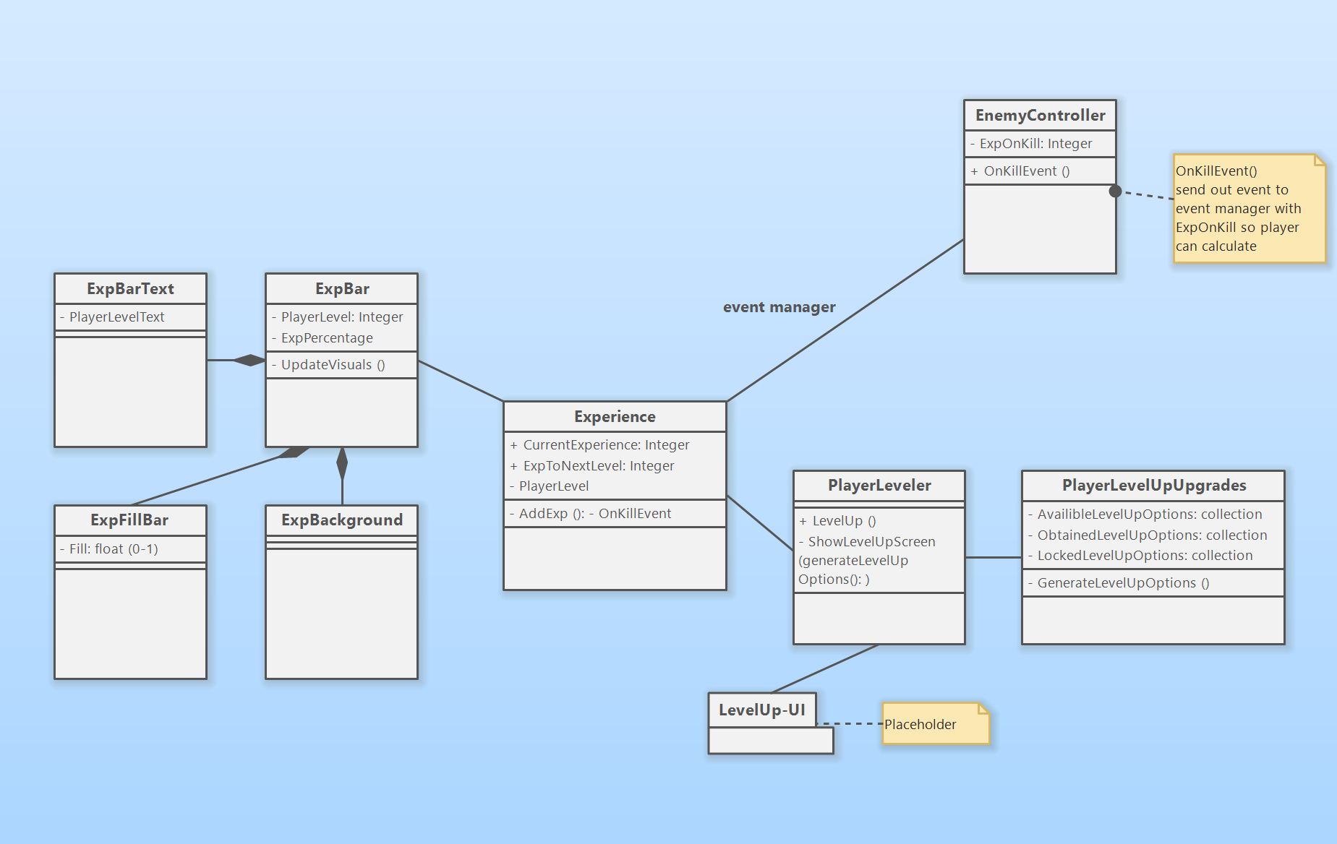
The first version of the technical design was partly a guess from me on how you could do something like this because I had never done anything like it. This is particularly the case for the PlayerLevelUpUpgrades part.
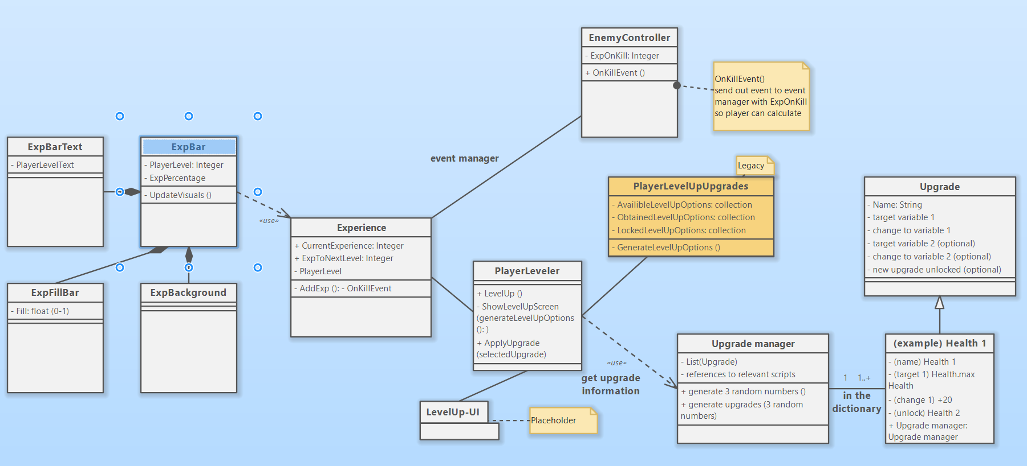
A little bit later into the project I had an idea for how to make the Upgrades more expandable by making a class as a sort of template and making all the possible upgrades instances of that script. However, it turned out to be cumbersome and I went back to the original method
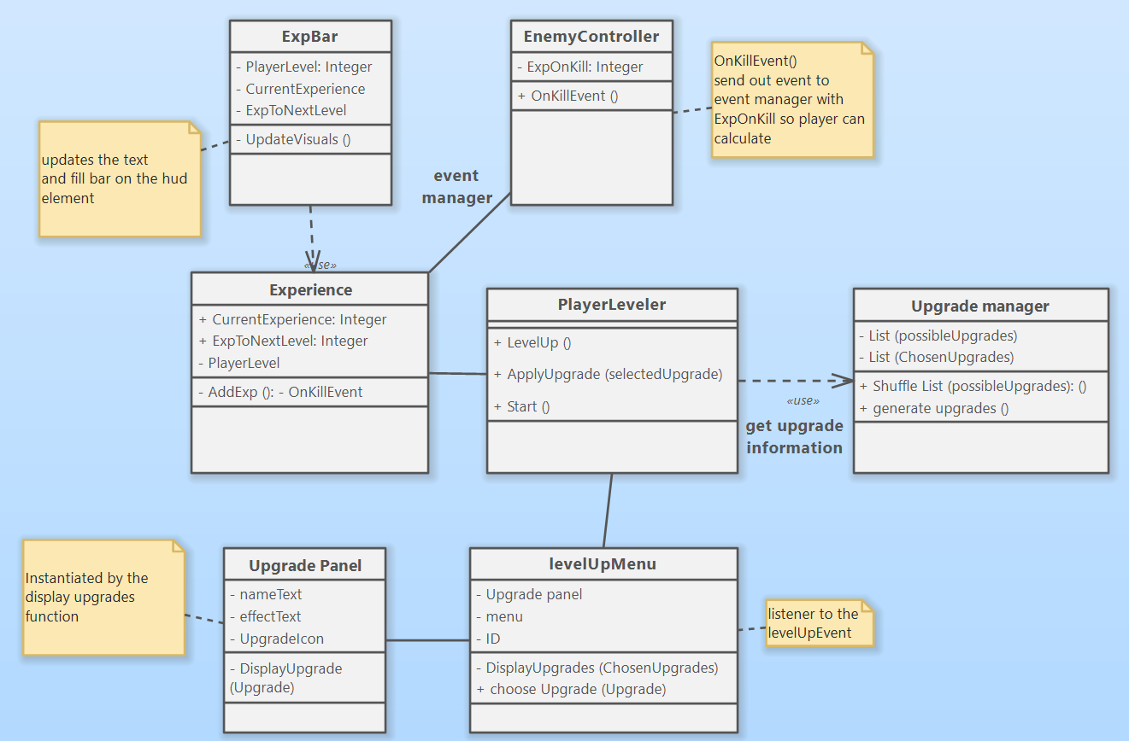
This diagram is what the final structure of the scripts looks like. With the playerLeveler activating the levelUpMenu through an event and a button on the upgrade panel triggering the choose upgrade function.
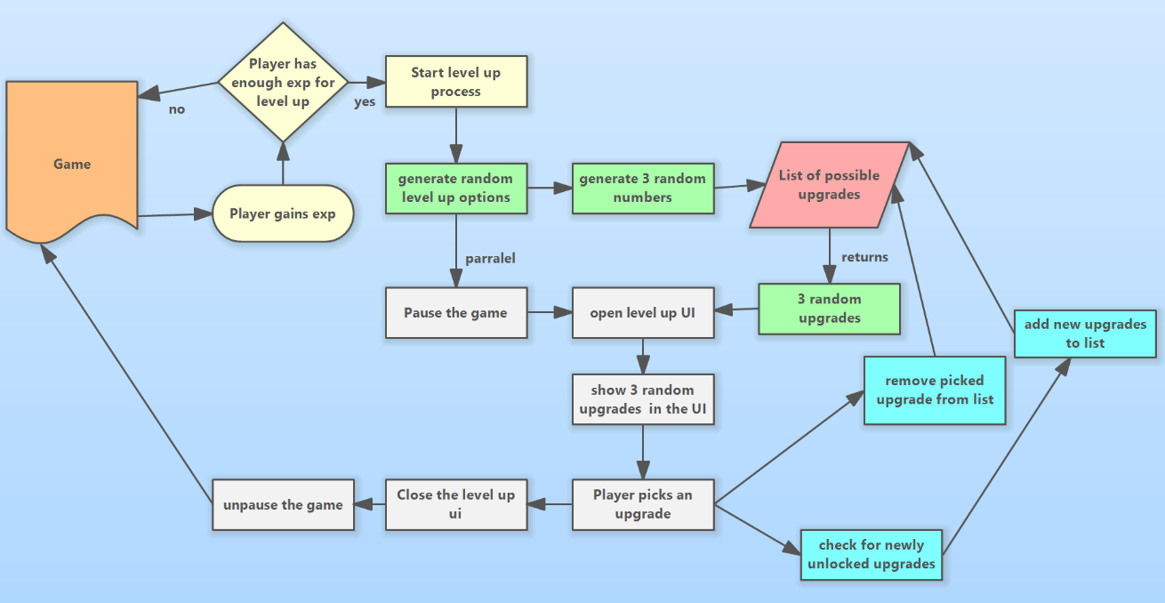
This is a flowchart I made to help myself get an overview of what the sequence of events was and what triggered what.
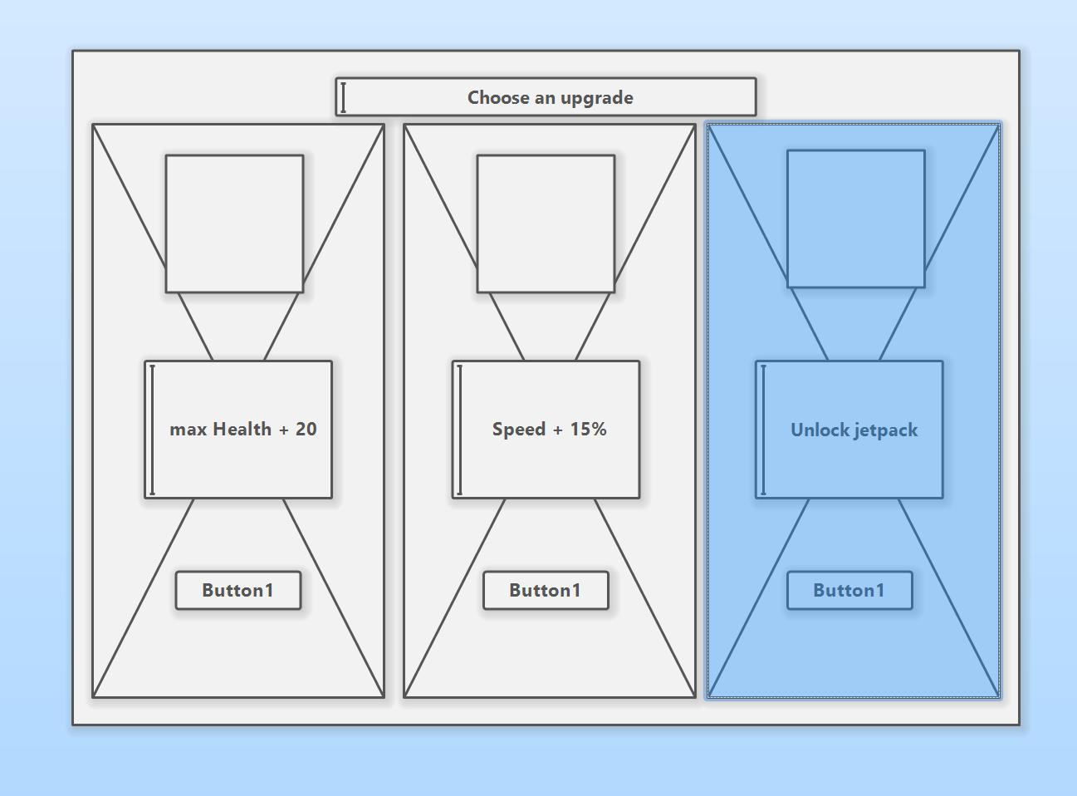
This was a sketch of what the UI would look like with the three panels and the button at the bottom.

Expandability
If you want to add a new upgrade these are the things you have to do.
- Add the name of the upgrade to playerUpgrade List<PossibleUpgrades>
- Add a case to levelUpPanel DisplayUpgrade switch(upgrade) with the text/image you want in the UI
- Add a case to playerLeveler applyUpgrade switch(selectedUpgrade) effect you want the upgrade to have
- Add any missing script references to the playerLeveler
If you want to implement level scaling:
- Add a line to Experience Update with the formula for required exp

User guide
As a player you interact with the leveling system, I have created by killing enemies. Killing enemies gives the player experience, once the player has enough experience they will level up and the level up menu will pop up and the game will pause. In the level up menu, you will see three upgrades randomly selected from a list of possible upgrades (currently 6 upgrades long). You select one of these upgrades by clicking the corresponding button at the bottom. When you select an upgrade the menu will disappear and the game will resume.
The experience obtained by killing an enemy is found in the inspector under the ‘loot’ heading.
the current progress toward the next level up and the current level can be found in de bottom left corner of the screen.

Reflection
During this assignment I learned a lot about Class diagrams and the value of UML when working in a development team. I also feel I made a lot of strides in my understanding of how to write better code with OOP and design patterns, spesifically design patterns will greatly change how I write code for projects from now on.
The development of the feature itself was a good experience that I believe was generally successful in not only following the codebase established by the FPS project but also helped me a lot in better understanding how to make a roguelike game.

Resources
The UML diagram software I used was Software Ideas Modeler.

